PROJECT SUMMARY
Stavatti Aerospace Ltd
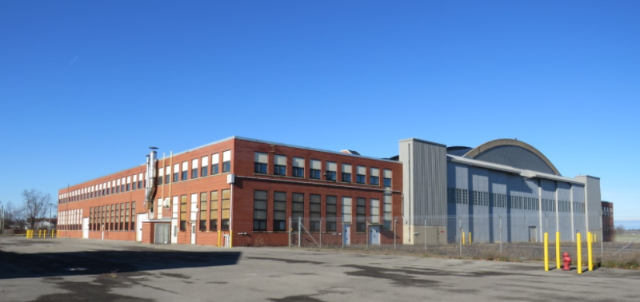
Applicant: | Stavatti Aerospace Ltd
Project Location: | 9400 Porter Road  Town of Niagara NY
Assistance: | 15 Year PILOT  Sales Tax Abatement  Mortgage Recording Tax Abatement
Description: | This project entails Stavatti Aerospace Ltd’s purchase of the vacant 150,000 sq. ft. former U.S. Army Reserve Station hangar for the purpose of establishing an aircraft research, design and prototyping facility. This facility will serve as a temporary headquarters for the company.  The former USARC Buildings will be repaired, modified, and improved and new machinery & equipment will be installed, as well as new energy efficient HVAC systems.
Project Costs: | Property Acquisition  Construction/Improvements  Furniture, Fixtures & Equipment  Soft costs & other  TOTAL | $ 1,300,000  $ 3,500,000  $ 5,800,000  $15,275,000  $ 25,875,000
Employment: | Current jobs in Niagara County 0  New Jobs in Niagara County within 3 years: 363  Total Annual Payroll End Year 3: $ 48,440,258  Skills: Management, Professional, Administrative, Production
Evaluative Criteria: | Age of Structure, Building or Facility Vacancy, Redevelopment Supports or aligns with Regional or Local Development Plans, Regional Wealth Creation, Investments in Energy Efficiency.

REGIONAL ECONOMIC IMPACT ANALYSIS
Stavatti Aerospace Ltd

Estimated State & Regional Benefits / Estimated Project Incentives Analysis
Total State and Regional Benefits |  | $ 85,170,821
Total Project Incentives |  | $ 2,150,092
Community Benefit to Cost Ratio |  | 39.61:1
Projected Employment | State | Region
Total Employment | 1,214 | 1,214
Direct** | 389 | 389
Indirect*** | 790 | 790
Temporary Construction (Direct and Indirect) | 35 | 35

Estimated State & Regional Benefits (Discounted Present Value*)
Total State and Regional Benefits | $85,170,821
Income Tax Revenue | $ 66,677,000
Sales Tax Revenue | $ 17,912,000
Property Tax Revenue | $ 581,821

Estimated Project Incentives (Discounted Present Value*)  Total Project Incentives | $2,150,092
Property Tax | $ 1,371,436
Sales Tax | $ 604,000
Mortgage Tax | $ 174,656

* Figures over 15 years and discounted by 3.49%
** Direct - The recipient of IDA assistance adds new jobs to the regional economy and/or retains jobs at risk of being lost to another region. Investments that result in displacing existing jobs (e.g., most retail and many service sector industries) do not fall under this definition.
*** Indirect - The recipient of IDA assistance makes purchases from regional firms, which stimulates suppliers to add jobs and payroll that are new to the regional economy or are saved from being lost to competitors outside the region.
**** Induced - The recipient of IDA assistance by adding to and/or retaining payroll stimulates household spending that is new to the regional economy and/or saved from being lost to competitors outside the region.

Utilizing informANALYTICS modeling software, an economic impact analysis was conducted to measure new investment and employment for the project. This software is a widely accepted and an industry standard for economic impact modeling measuring employment and salary impacts and facility output on the community for a given project.

