PROJECT SUMMARY
Vincent Properties, Inc.
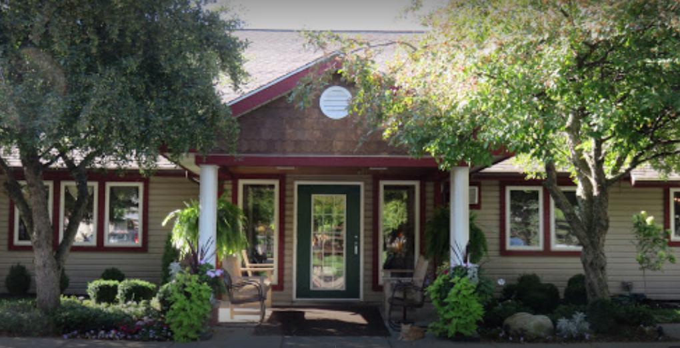

 | Vincent Properties, Inc.
Project Location: | 41 Lexington Court and adjacent addresses  City of Lockport
Assistance: | 15 Year fixed payment PILOT  Mortgage Recording Tax Abatement
Description: | Vincent Properties is a non-profit owner of assisted living facilities in Western New York. The Company is under contract to purchase the Heritage Manor of Lockport, a 40 room (64 bed) adult home which provides long-term residential care, room, board, housekeeping, personal care and supervision. The project will entail cosmetic improvements and other facility updates, as needed.  The Company is also under contract to purchase Heritage Manor Estates, which consists of twelve, single floor duplex senior apartments located adjacent to Heritage Manor. Each apartment has two bedrooms, an attached garage and private laundry facilities, all configured in an ADA accommodating layout.  The Company plans to operate these facilities, together with Wheatfield Commons (which offers memory care units) as a senior housing community that can provide a continuum of care, with varying levels from senior independent living through assisted living and memory care.  The applicant has requested a deviated PILOT agreement with the NCIDA with fixed annual payments in the amount of $10,000 for Heritage Manor, plus $70,000 for Heritage Estates. Annual payments would increase 2% annually. The PILOT term would be 15 years. The project will provide continued funding for essential emergency services and will continue to preserve the Heritage Manor and Estates as quality facility for seniors in the County.
Project Costs: | Property Acquisition  Construction/Improvements  TOTAL | $ 6,400,000  $ 250,000  $ 6,650,000
Employment: | Current jobs in Niagara County 20  New Jobs in Niagara County within 3 years: 2  Total Annual Payroll End Year 3: $732,576  Skills: Administrative, Personal Care, Housekeeping, Maintenance
Evaluative Criteria: | Age of Structure, Redevelopment Supports or aligns with Regional or Local Development Plans, Regional Wealth Creation

REGIONAL ECONOMIC IMPACT ANALYSIS
Vincent Properties, Inc.

Estimated State & Regional Benefits / Estimated Project Incentives Analysis
Total State and Regional Benefits |  | $2,381,468
Total Project Incentives |  | $ 732,248
Community Benefit to Cost Ratio |  | 3.25:1
Projected Employment | State | Region
Total Employment | 37 | 37
Direct** | 22 | 22
Indirect*** | 12 | 12
Temporary Construction (Direct and Indirect) | 3 | 3

Estimated State & Regional Benefits (Discounted Present Value*)
Total State and Regional Benefits | $2,381,468
Property Tax Revenue | $ 1,383,468
Income Tax Revenue | $ 736,000
Sales Tax Revenue | $ 262,000

Estimated Project Incentives (Discounted Present Value*)  Total Project Incentives | $732,248
Property Tax | $ 690,874
Mortgage Tax | $ 41,374

* Figures over 15 years and discounted by 3.49%
** Direct - The recipient of IDA assistance adds new jobs to the regional economy and/or retains jobs at risk of being lost to another region. Investments that result in displacing existing jobs (e.g., most retail and many service sector industries) do not fall under this definition.
*** Indirect - The recipient of IDA assistance makes purchases from regional firms, which stimulates suppliers to add jobs and payroll that are new to the regional economy or are saved from being lost to competitors outside the region.
**** Induced - The recipient of IDA assistance by adding to and/or retaining payroll stimulates household spending that is new to the regional economy and/or saved from being lost to competitors outside the region.

Utilizing informANALYTICS modeling software, an economic impact analysis was conducted to measure new investment and employment for the project. This software is a widely accepted and an industry standard for economic impact modeling measuring employment and salary impacts and facility output on the community for a given project.

