PROJECT SUMMARY
Zimmie’s Service

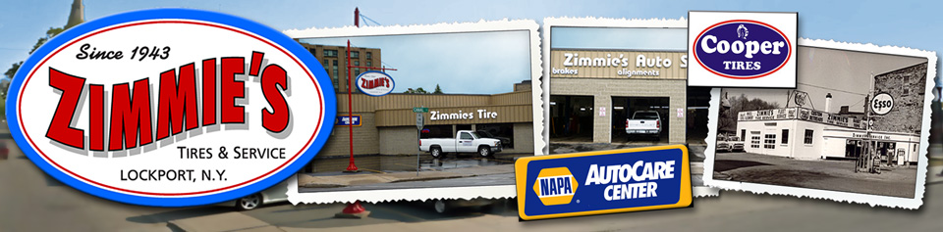
Applicant: | Zimmie’s Service
Project Location: | 1 Niagara Street  City of Lockport, 14094
Assistance: | 10 Year PILOT  Sales Tax Abatement  Mortgage Recording Tax Abatement
Description: | Zimmie's is a full service auto repair and maintenance shop, the family-owned and operated shop has been serving Lockport and the greater Western New York region since 1943.  A 1,200 square feet portion of the existing structure will be torn down, and rebuilt twice as large. A new 4 post truck lift, and a 2 post car lift will be installed to enhance the function and capabilities of the shop.
Project Costs: | Construction/Improvements  Furniture, Fixtures & Equipment  TOTAL | $ 400,000  $ 35,000  $ 435,000
Employment: | Current jobs in Niagara County 6.5  New Jobs in Niagara County within 3 years: 1  Total Annual Payroll End Year 3: $ 488,460  Skills: Management, Administrative, Production
Evaluative Criteria: | Distressed Census Tracts, Age of Structure, Regional Wealth Creation, Redevelopment Supports or aligns with Regional or Local Development Plans.

REGIONAL ECONOMIC IMPACT ANALYSIS
Zimmie’s Service

Estimated State & Regional Benefits / Estimated Project Incentives Analysis
Total State and Regional Benefits |  | $ 565,053
Total Project Incentives |  | $ 142,211
Community Benefit to Cost Ratio |  | 3.97:1
Projected Employment | State | Region
Total Employment | 17 | 17
Direct** | 7 | 7
Indirect*** | 6 | 6
Temporary Construction (Direct and Indirect) | 4 | 4

Estimated State & Regional Benefits (Discounted Present Value*)
Total State and Regional Benefits | $ 565,053
Income Tax Revenue | $ 332,000
Property Tax Revenue | $ 134,053
Sales Tax Revenue | $ 99,000

Estimated Project Incentives (Discounted Present Value*)  Total Project Incentives | $ 142,211
Property Tax | $ 120,786
Sales Tax | $ 18,800
Mortgage Tax | $ 2,625

* Figures over 15 years and discounted by 3.49%
** Direct - The recipient of IDA assistance adds new jobs to the regional economy and/or retains jobs at risk of being lost to another region. Investments that result in displacing existing jobs (e.g., most retail and many service sector industries) do not fall under this definition.
*** Indirect - The recipient of IDA assistance makes purchases from regional firms, which stimulates suppliers to add jobs and payroll that are new to the regional economy or are saved from being lost to competitors outside the region.
**** Induced - The recipient of IDA assistance by adding to and/or retaining payroll stimulates household spending that is new to the regional economy and/or saved from being lost to competitors outside the region.

Utilizing informANALYTICS modeling software, an economic impact analysis was conducted to measure new investment and employment for the project. This software is a widely accepted and an industry standard for economic impact modeling measuring employment and salary impacts and facility output on the community for a given project.

