PROJECT SUMMARY
Buffalo Fuel Corp.

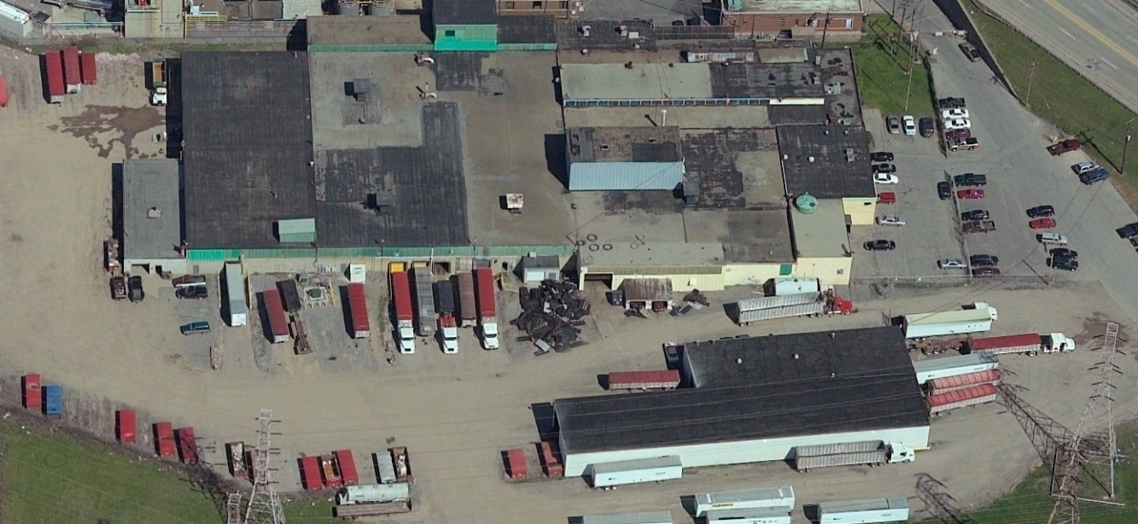
Applicant: | Buffalo Fuel Corp.
Project Location: | 4870 Packard Rd  City of Niagara Falls
Assistance: | 15 Year PILOT  Sales Tax Abatement  Mortgage Recording Tax Abatement
Description: | A 32,000 square foot ClearSpan building will be built, to be used as a TSD (Treatment, Storage, and Disposal) facility.  The Building will also function as a recycling facility, and will be leased to SGS Recovery.  Offices and bathrooms in the existing building, as well as the truck and maintenance shop will be renovated into a warehouse for fiber storage.
Project Costs: | Construction/Improvements  Furniture, Fixtures & Equipment  Soft costs & other  TOTAL | $ 1,917,000  $ 300,000  $ 23,000  $ 2,240,000
Employment: | Current jobs in Niagara County 23  New Jobs in Niagara County within 3 years: 11  Total Annual Payroll End Year 3: $1,471,922  Skills: Management, Administrative, Production
Evaluative Criteria: | Distressed Census Tract Eligible, Regional Wealth Creation

REGIONAL ECONOMIC IMPACT ANALYSIS
Buffalo Fuel Corp.

Estimated State & Regional Benefits / Estimated Project Incentives Analysis
Total State and Regional Benefits |  | $ 2,563,621
Total Project Incentives |  | $ 527,141
Community Benefit to Cost Ratio |  | 4.86:1
Projected Employment | State | Region
Total Employment | 102 | 102
Direct** | 34 | 34
Indirect*** | 23 | 23
Induced**** | 26 | 26
Temporary Construction (Direct and Indirect) | 19 | 19

Estimated State & Regional Benefits (Discounted Present Value*)
Total State and Regional Benefits | $ 2,563,621
Income Tax Revenue | $ 1,633,315
Sales Tax Revenue | $ 552,249
Property Tax Revenue | $ 378,057

Estimated Project Incentives (Discounted Present Value*)  Total Project Incentives | $ 527,141
Property Tax | $ 409,661
Sales Tax | $ 100,680
Mortgage Tax | $ 16,800

* Figures over 15 years and discounted by 3.49%
** Direct - The recipient of IDA assistance adds new jobs to the regional economy and/or retains jobs at risk of being lost to another region. Investments that result in displacing existing jobs (e.g., most retail and many service sector industries) do not fall under this definition.
*** Indirect - The recipient of IDA assistance makes purchases from regional firms, which stimulates suppliers to add jobs and payroll that are new to the regional economy or are saved from being lost to competitors outside the region.
**** Induced - The recipient of IDA assistance by adding to and/or retaining payroll stimulates household spending that is new to the regional economy and/or saved from being lost to competitors outside the region.

Utilizing informANALYTICS modeling software, an economic impact analysis was conducted to measure new investment and employment for the project. This software is a widely accepted and an industry standard for economic impact modeling measuring employment and salary impacts and facility output on the community for a given project.

